Supported Employment – Kitchen Steward

Location: 23 County Road, Maidstone, Kent
Wage: Government minimum wage (£7.83)
Paid into bank account monthly

Hours: 8am-4pm

Lunch time: 11:30am-12:15pm
Afternoon break: 2:30pm – 2:45pm

- Ensuring the washing up is completed to a good standard as and when required.

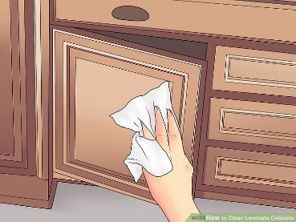
- Cupboards kept clean and in order.

- Appliances kept clean and checked for working order.

- List replenishment and purchase of office sundries, such as milk, coffee, sugar, tea.

- Receiving and making beverage orders within specific times throughout the day using the appropriate utensils.

- Once a week organising and planning a simple healthy lunch for all office staff. Planning and prepping the lunch within a budget and to individual requirements.

- Sweep and mop floor and leave kitchen area clean and tidy ready for the next team.

Goal / Target for applicant: To create a strong CV through paid supported employment and undertake training as necessary.

Working Environment and Responsibilities
- We have a clear desk policy; no sensitive information should be left on the desks when you are away from your desk for a long period of time.
- No eating at your desk.
- At all times you should look professional, this is through professional clothing, clean hair and clean hands.
- You should always wear appropriate and sensible footwear. The appropriate dress code is; smart casual, no opened toe shoes (flip flops or sliders). Hands and nails should be clean and tidy.
- If you need to buy any items for the office, this is paid on the Office Pay Card.
- If you are required to take medication throughout the day, please make sure you bring this with you.

Health and Safety
In carrying out the tasks in this job description you have a duty (under Health and Safety Legislation) to take responsible care for the Health and Safety of yourself and that of others. This implies taking positive steps to understand the hazards in the work place, to evaluate and take actions to reduce risks. It is expected that you comply with the safety rules and procedures and to ensure that nothing you do, or fail to do, puts yourself or others at risk.
To remain vigilant and to do everything possible to protect yourself and others from abuse of a physical, emotional, sexual neglectful, financial or institutional nature. This includes an absolute requirement to report any incident of this nature you witness, hear about or suspect.

As part of your role you will be required to complete the following training:
- Health and Safety
- Manual Handling
- Hospitality

Signed: ___________________________

Print Name:________________________

Date:_____________________________

Witness Signature:__________________

Print Name:________________________

Date:______________________________

